ClubUML

[Sequence Diagram Integration]

ClubUML Task Design Specification

[Zessie]

Draft: 2013-02-02

Table of Contents

Introduction 3

Tools 4

UML Generation Tool 4

Graphing Tool 4

Possible Solution Details 5

Class Diagram Visualization Flow 5

Sequence Diagram Available Visualization Flow 5

Details 5

To do Task 9

# Introduction

For the possible extension to integrate sequence diagram in our existing project, I created this document with possible solution.

# Tools

## UML Generation Tool

Papyrus

## Graphing Tool

UMLGraph

pic2plot - <http://www.gnu.org/software/plotutils/plotutils.html>

# Possible Solution Details

## Class Diagram Visualization Flow

Ecore File -> Java File (Which defines the structure of class diagram)-> Dot File -> png File

Ecore File is under:

ClubUMLLocalTest->WebContent->EcoreFiles

Java Generation Code is under :

ClubUMLLocalTest->controller->DiagramFactory.java->createJavaFile() method

Png Generation Code is under:

ClubUMLLocalTest->controller->DiagramFactory.java->createPngFile() method

## Sequence Diagram Possible Visualization Flow

Since it is possible for us to continue with umlgraph to support sequence diagram, the umlgraph visualization flow will be as followed:

Papyrus sequence model -> pic macros(define objects and method invocation)->pic2plot (create png file)

## Details

1. The papyrus sequence diagram architecture:



1. Sequence Diagram

This is a really simple example I created using papyrus for further testing:

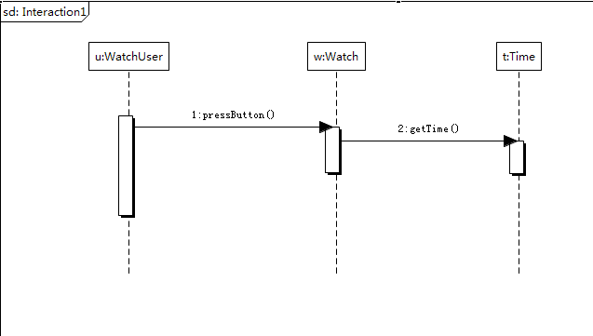

This is the code papyrus created in sequence.uml file:

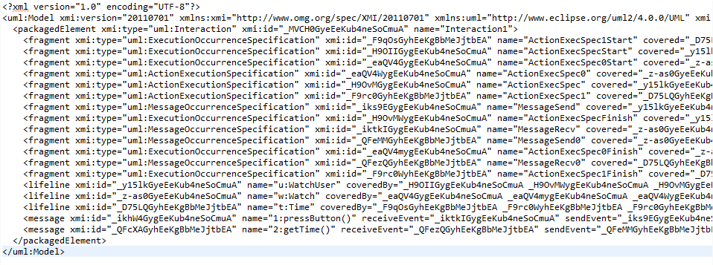

1. Pic Definition file

This is an example found from umlgraph documentation:

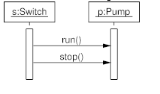

Pic file definition is like that:

.PS  
copy "sequence.pic"; (not sure what this is yet)  
  
# Object definition  
object(S,"s:Switch");  
object(P,"p:Pump");  
step();  
active(S);  
active(P);  
  
# Message exchange  
message(S,P,"run()");  
message(S,P,"stop()");  
  
# Object lifeline completion  
step();  
complete(S);  
complete(P);  
.PE

As similar we can create pic file just like this for our sequence diagram:



.PS  
copy "sequence.pic"; (not sure what this is yet)  
  
# Object definition  
object(U,"u:WatchUser");  
object(W,"w:Watch");

object(T,"t:Time");

step();  
active(U);  
active(W);

active(T);  
  
# Message exchange  
message(U,W,"pressButton()");  
message(W,P,"getTime()");  
  
# Object lifeline completion

step();  
complete(U);  
complete(W);

complete(T);  
  
.PE

1. Convert pic file into png/gif file

Once you have sequence diagram definition file as .pic file, you can call the following to convert it into png/gif file.



*** All above is a summary from umlgraph documentation.

# To do Task

1. Since the limit for UMLGraph is that it can only support class diagram and sequence diagram types, we need further discussion on if we will stay with UMLGraph or we need to switch to a new tool.
2. Need further testing for the feasibility:

* Is the pic file created above accurate?
* Is the command working for creating png/gif file

1. If task 1 is finished, we further need to come up with the Algorithms to convert papyrus generated sequence diagram into a .pic file